**Spring 2024: CS5720**

**Neural Networks & Deep Learning - ICP-1**

**NAME: BALA RISHIK MARNENI  
STUDENT ID: 700746746**

**GITHUB LINK:** [**https://github.com/BalaRishik001/Neural-Networks-and-Deep-Learning-Assignments**](https://github.com/BalaRishik001/Neural-Networks-and-Deep-Learning-Assignments)

**VIDEO LINK:** [**https://drive.google.com/file/d/1pSxV7gOaFd3hDG5xXJA7dWmVRXi9EmQB/view?usp=drive_link**](https://drive.google.com/file/d/1pSxV7gOaFd3hDG5xXJA7dWmVRXi9EmQB/view?usp=drive_link)

1. Write a python program for the following:

* Input the string “Python” as a list of characters from console, delete at least 2 characters, reverse the resultant string and print it.

*Sample input:*

•python

• *Sample output:*

•ntyp

* Take two numbers from user and perform at least 4 arithmetic operations on them.   
  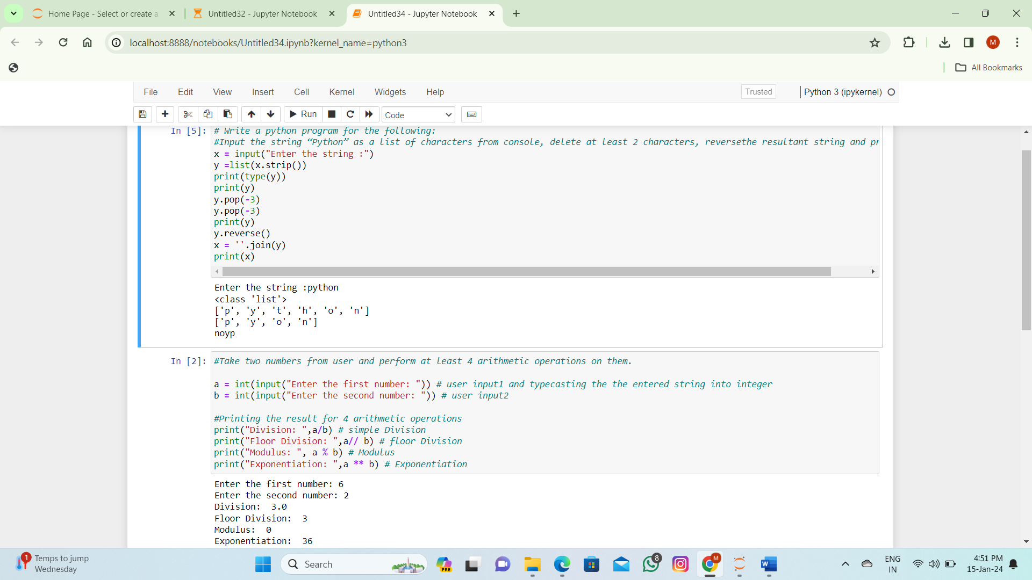

1. Write a program that accepts a sentence and replace each occurrence of ‘python’ with ‘pythons’.
   * *Sample input:*

•I love playing with python

* + *Sample output:*

•I love playing with pythons

1. Use the if statement conditions to write a program to print the letter grade based on an input class score. Use the grading scheme we are using in this class.

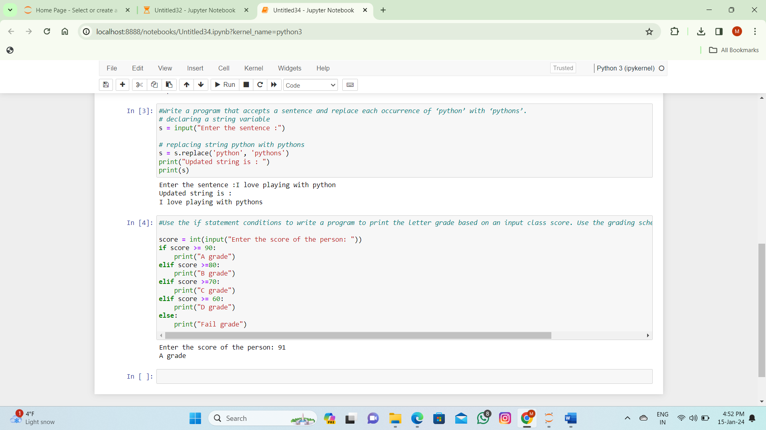  
  
 **THANK YOU**